**Excel Bot Design Document:**

**Design**

There are two excel Files,one file is considered as input file and the other is considered as a reference file.

**Stage1**

* Input File data-Table format.
* User can select the input and reference excel files.
* First a message box will be displayed asking to select an input file where user can select the input file.

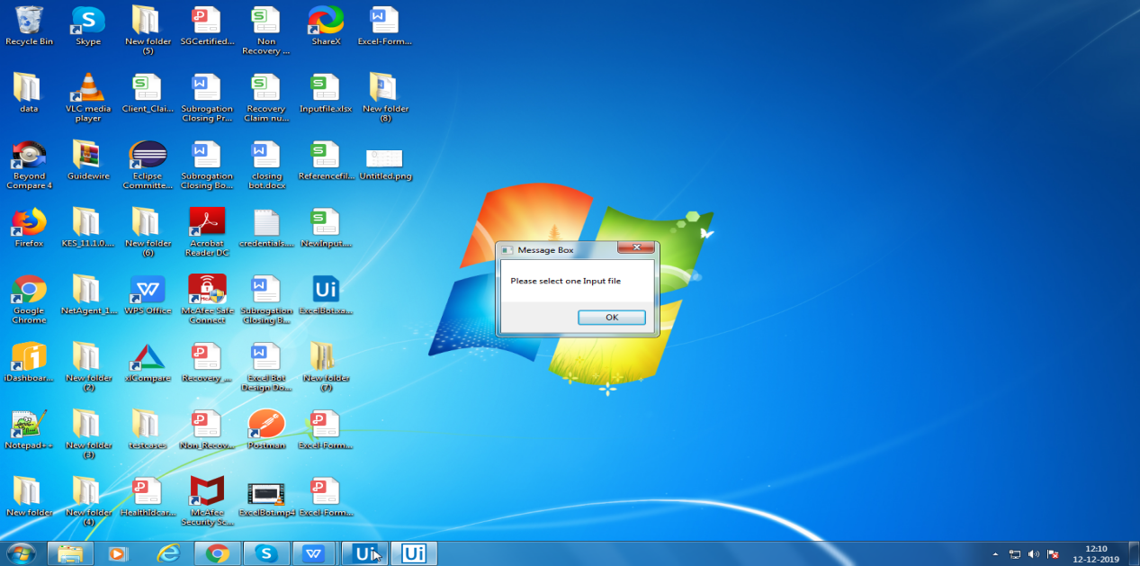

* Later,click on ‘ok’ in the message box,a window will be opened where the user can select the Excel file 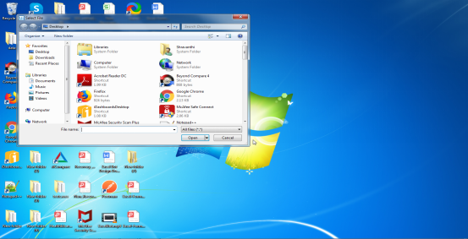
* After the input file is selected a pop up will be displayed asking the user to enter the sheet name.

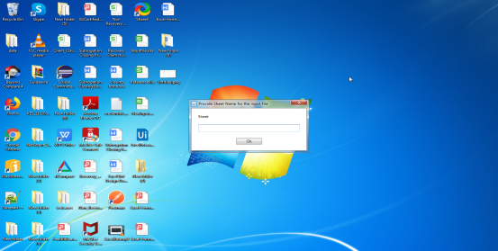

* After the sheet name is given,a message box will be displayed showing the table range as well as all the empty rows and columns from left and top portion of the excel will be removed.
* New Excel will be created with data copied to start from the first column and first row.
* Then the selection of the reference file is also in the same format.

Sample Input file:

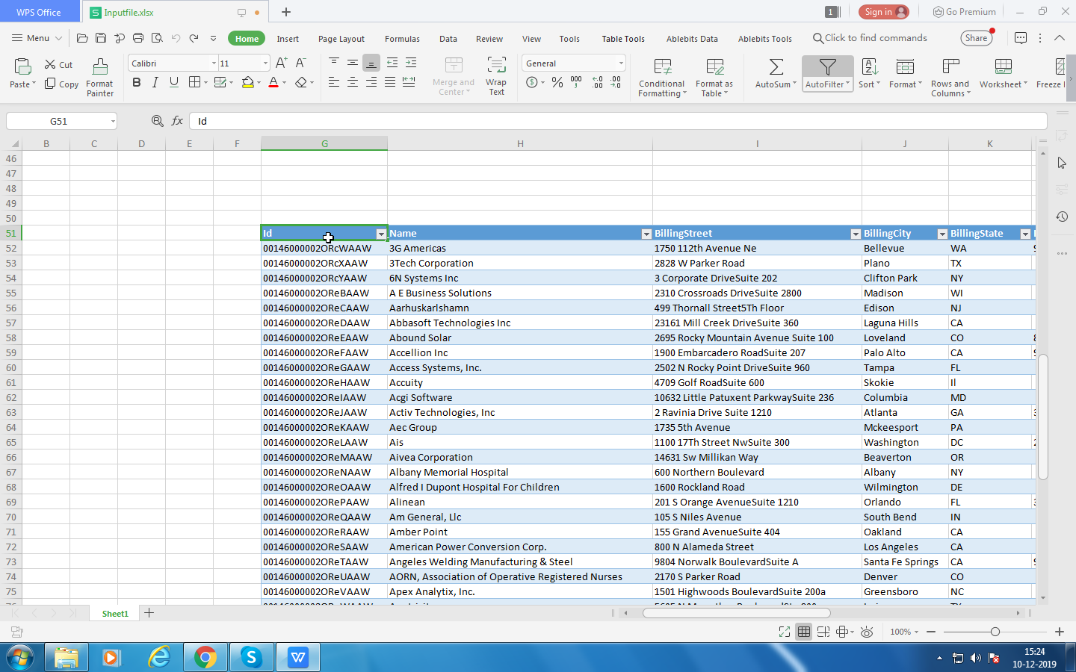

Sample New Input file:

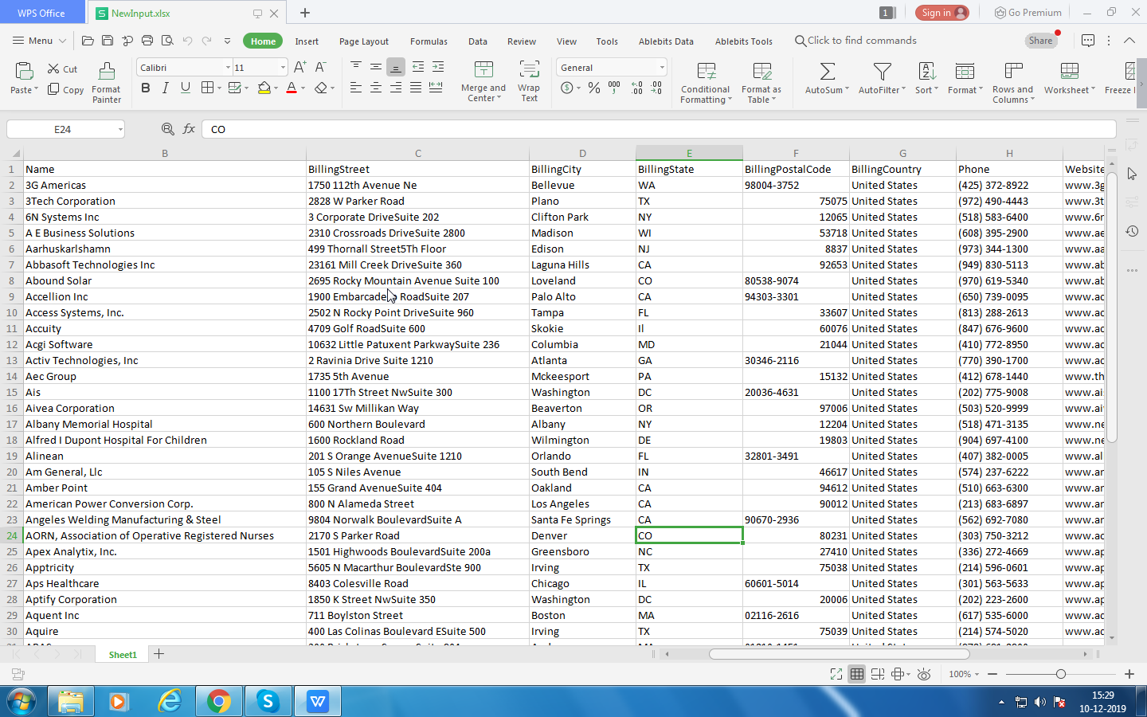

Sample Reference File:

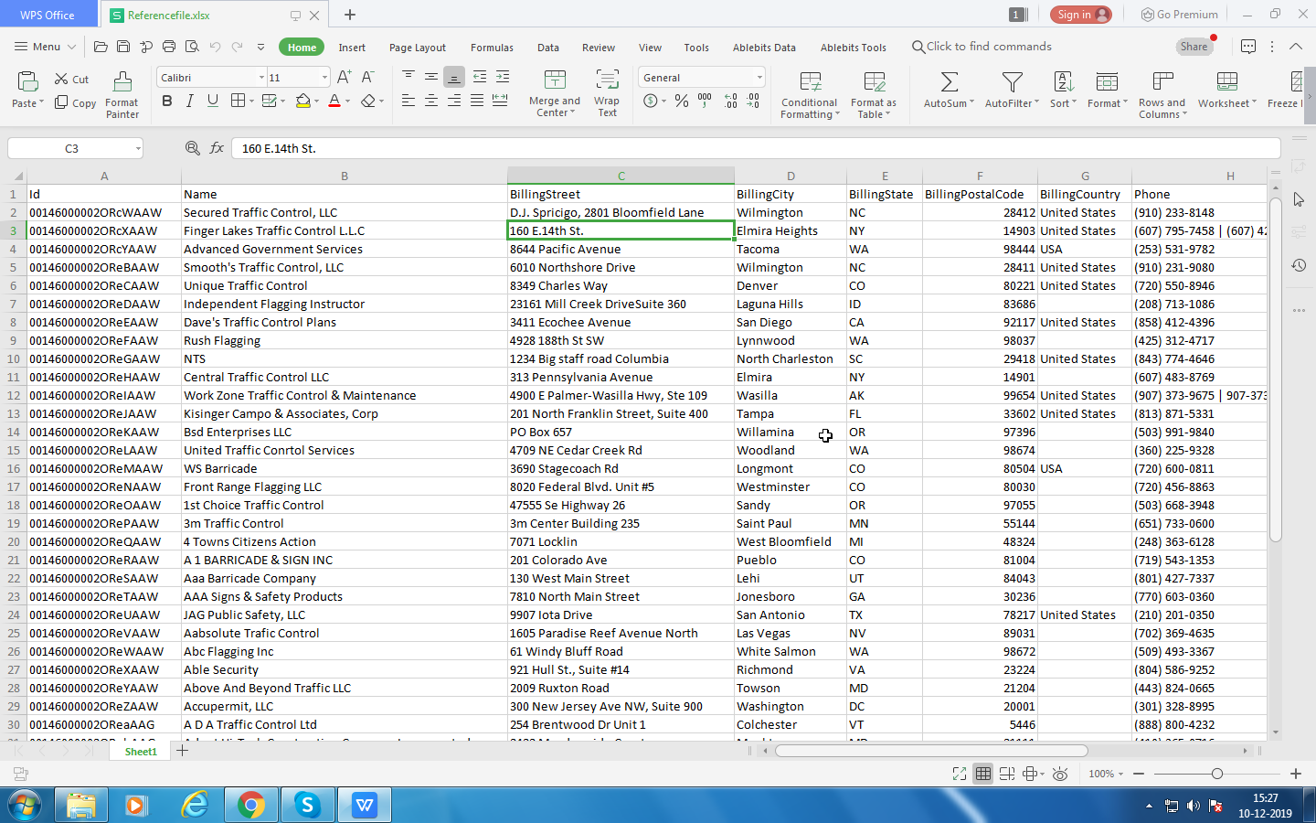

* A pop up will be displayed,asking user to enter the unique column name in the input file.
* Later verifies the column is not null and has unique data.
* If the column has null values and duplicate values,the bot should throw warning message to the user.
* Then the bot verifies whether the unique column of input file is present in the reference file.
* If the unique column is not present in the reference file,the bot should throw warning message to the user.
* Input file should contain all the columns that is present in the reference file.
* List of columns names in input and reference excel files will be displayed in the message box.

**Stage2**

* Form will be created.
* The form contains 5 input rows and 5 reference rows.
* In this form the user will be able to select 5 functions for the input file and 5 functions for the reference file.
* The bot will verify whether all the functions have input/reference fields.

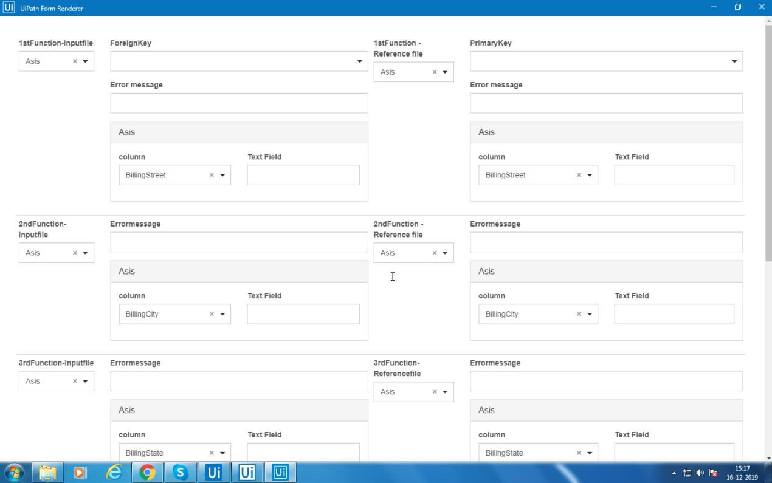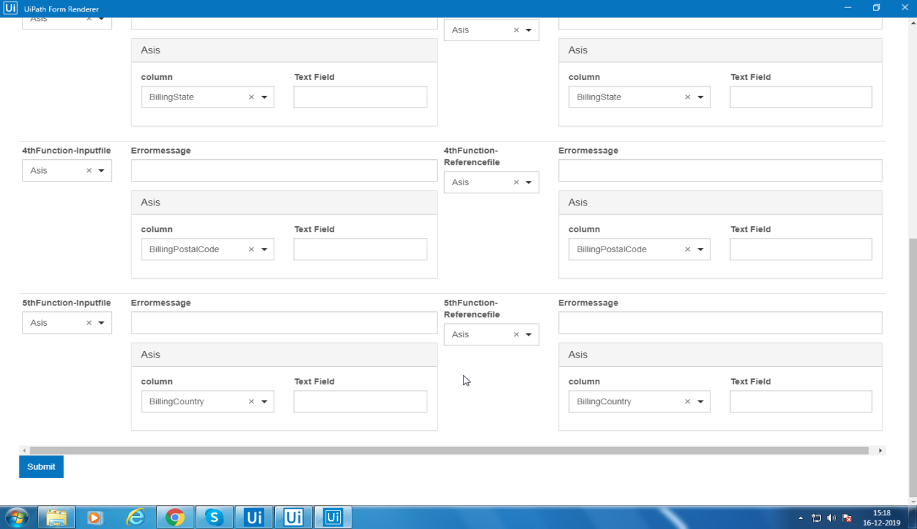

* The user can select one function from the dropdown.

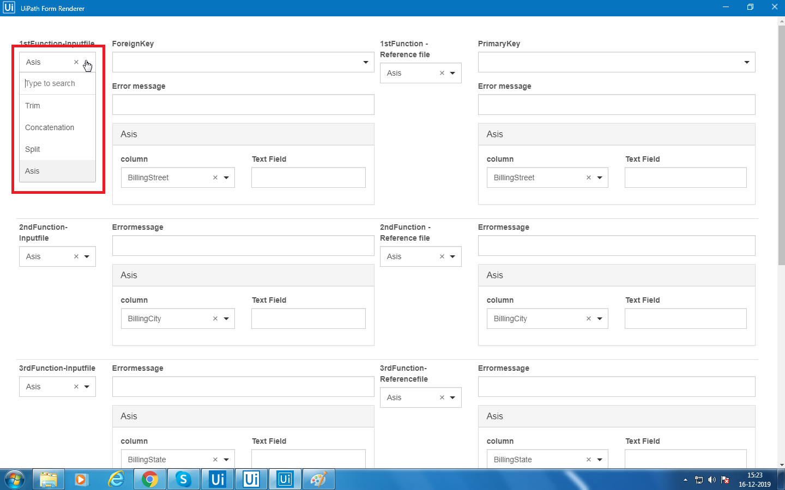

* If user selects one function,the bot should verify whether that function related fields are displayed and other functions fields are hidden.
* If user selects one function,the function related fields will be displayed and all the fields should contain a default value.
* Based on selection of the function by the user ,Number of columns will be displayed.

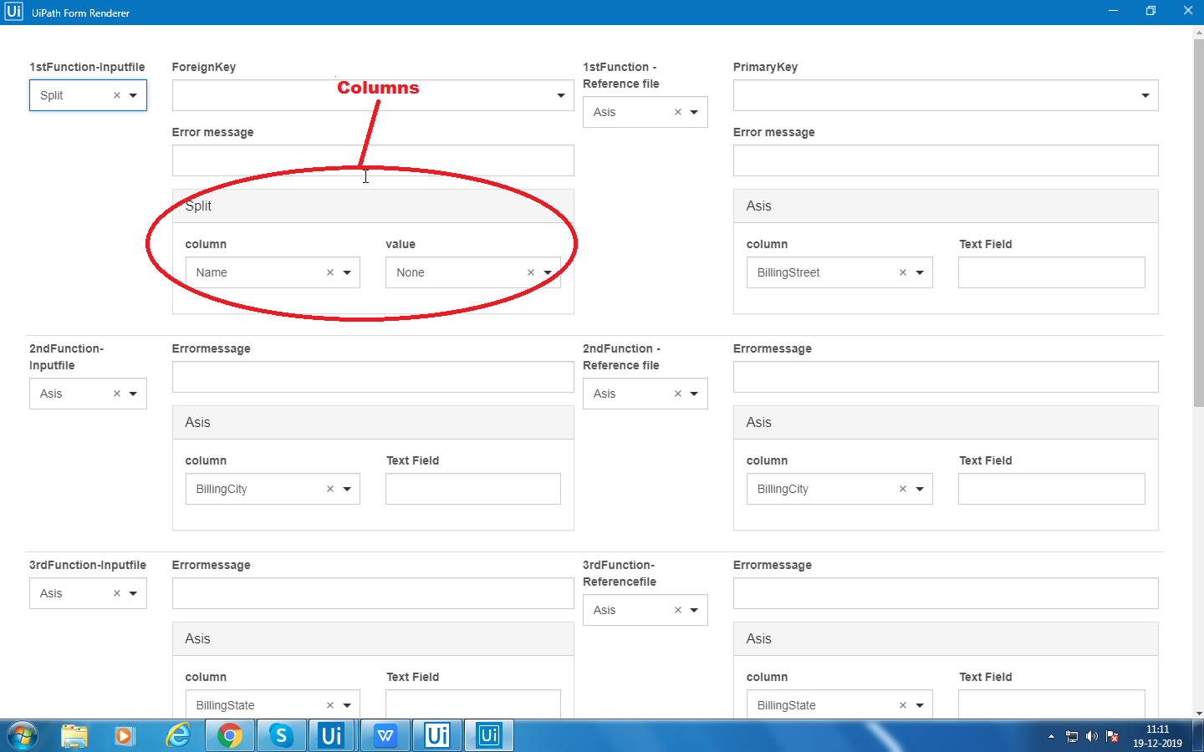

* By default one template(form) will be provided to the user.
* The user will make some changes and submit the form.
* If there are no validation errors,a dialog box appears for user confirmation to save the form.
* If there are any validations error the form will be opened again and user make changes regarding those errors and then the form will be submitted.

**Example**:How to use the form

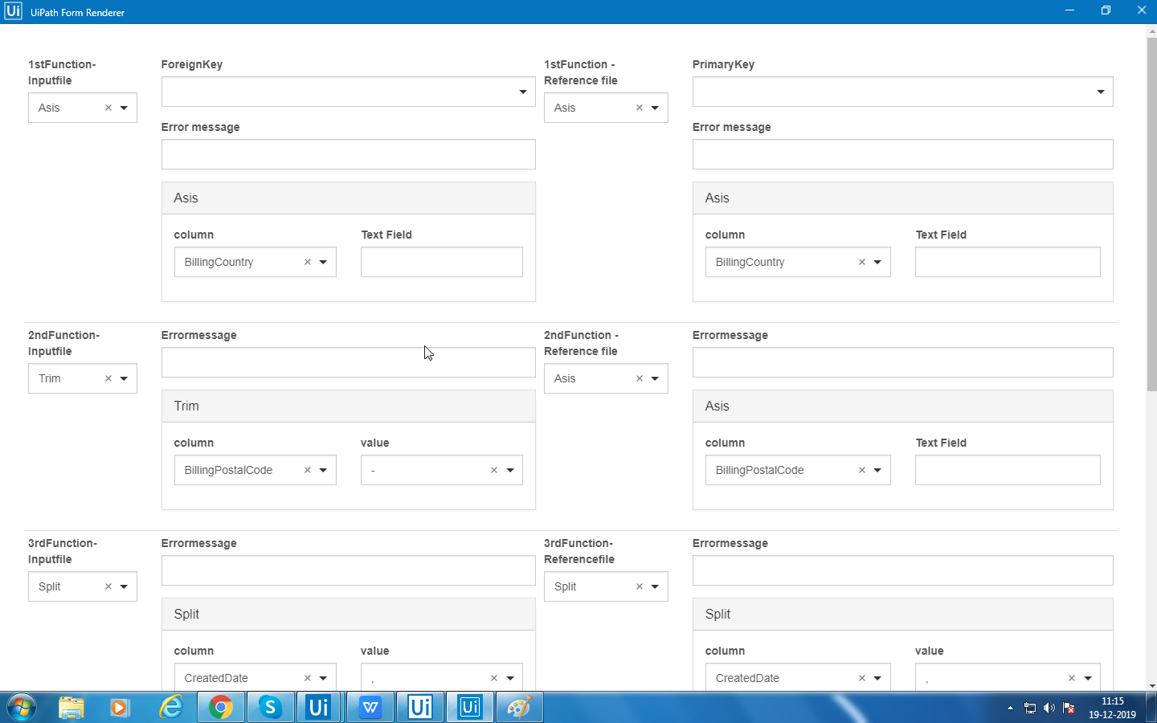

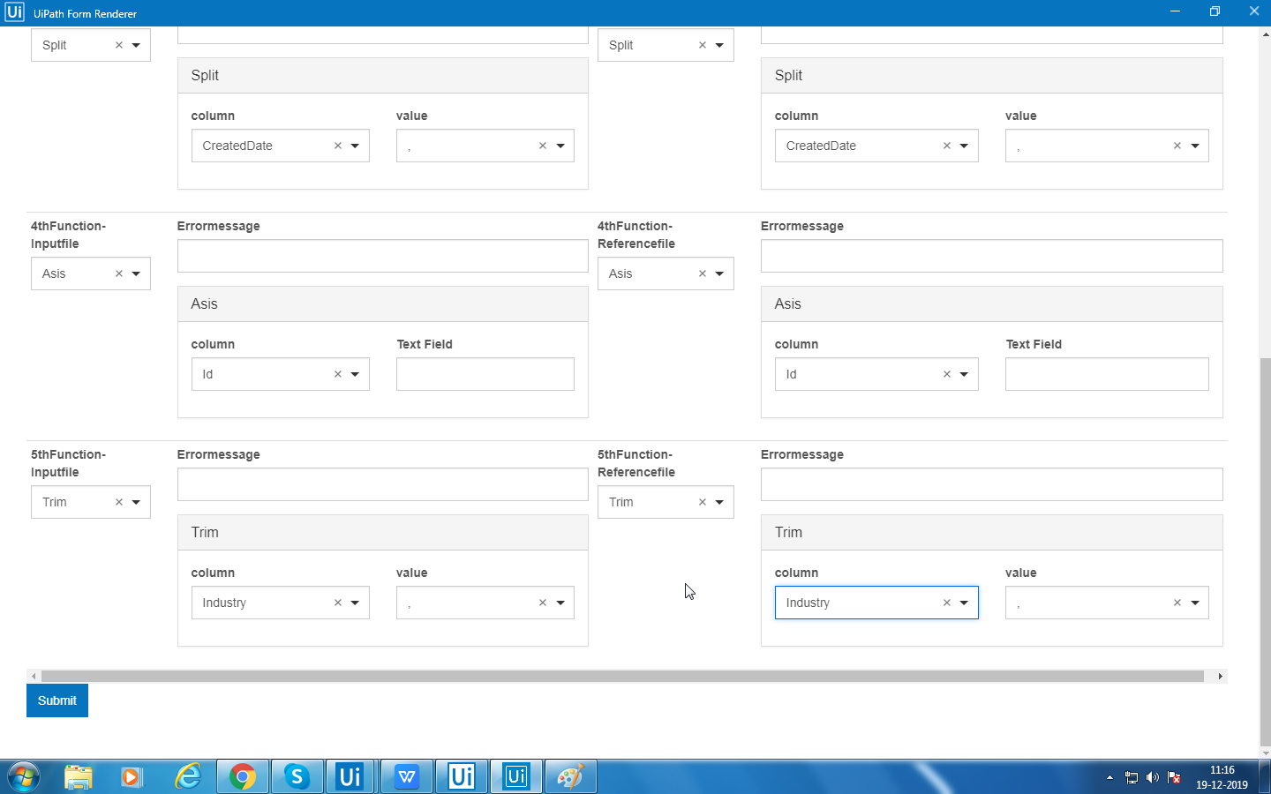

**Stage 3:**

* After user selects all the functions in the form in stage2,before the user submits the form a preview panel will be visible showing all the functions what user has selected.
* Then the output of the form for every function will be saved in the new excel file .
* The format of the output excel sheet.

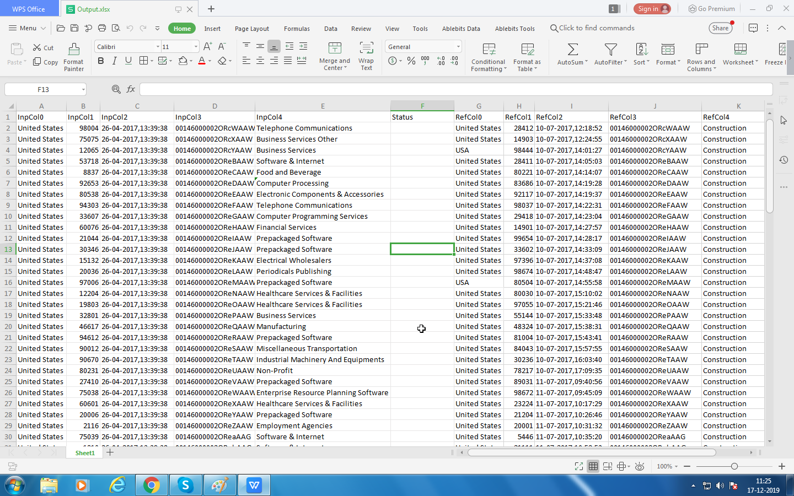

**Stage4:**

* After the output is stored in the excel sheet in stage 3,row to row comparison will happen for input columns and reference columns.
* Five columns of input file output will be compared to five columns of reference file output.
* The comparison status will be displayed in the status column.

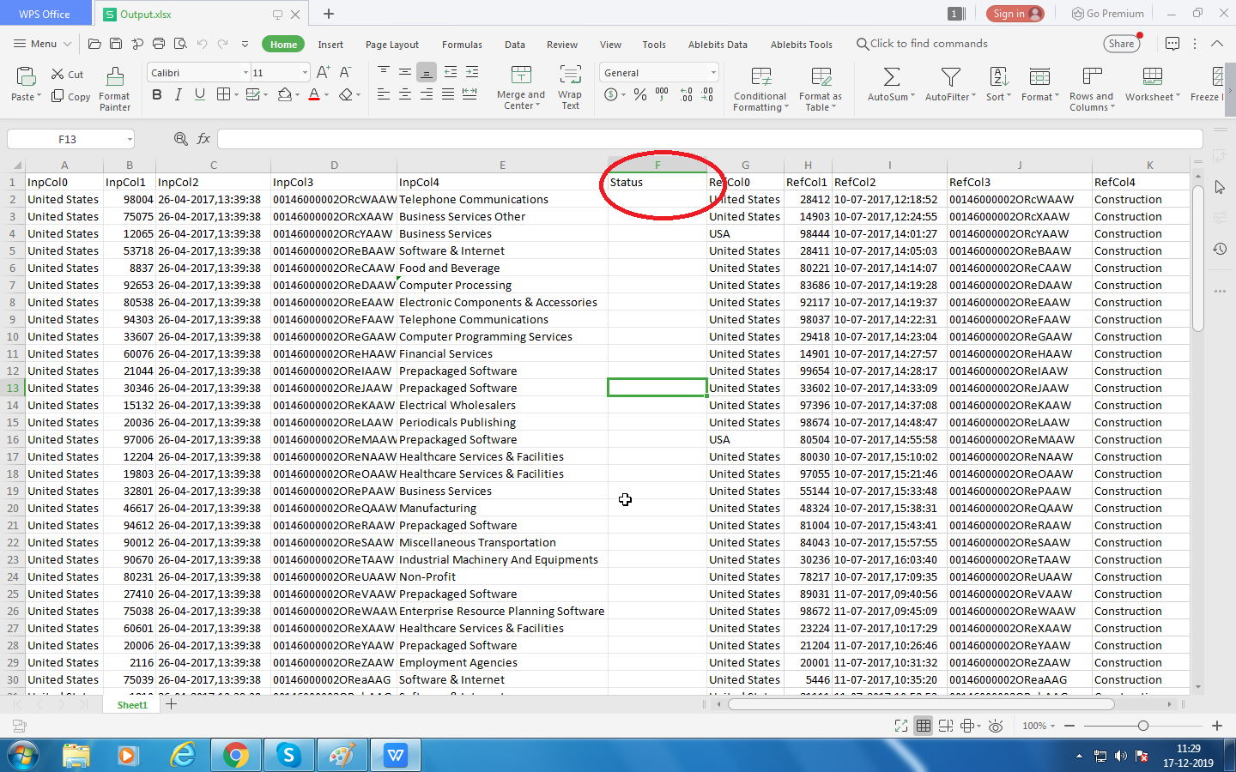

* First input column will be compared to first reference column, in the same way all the columns will be compared.

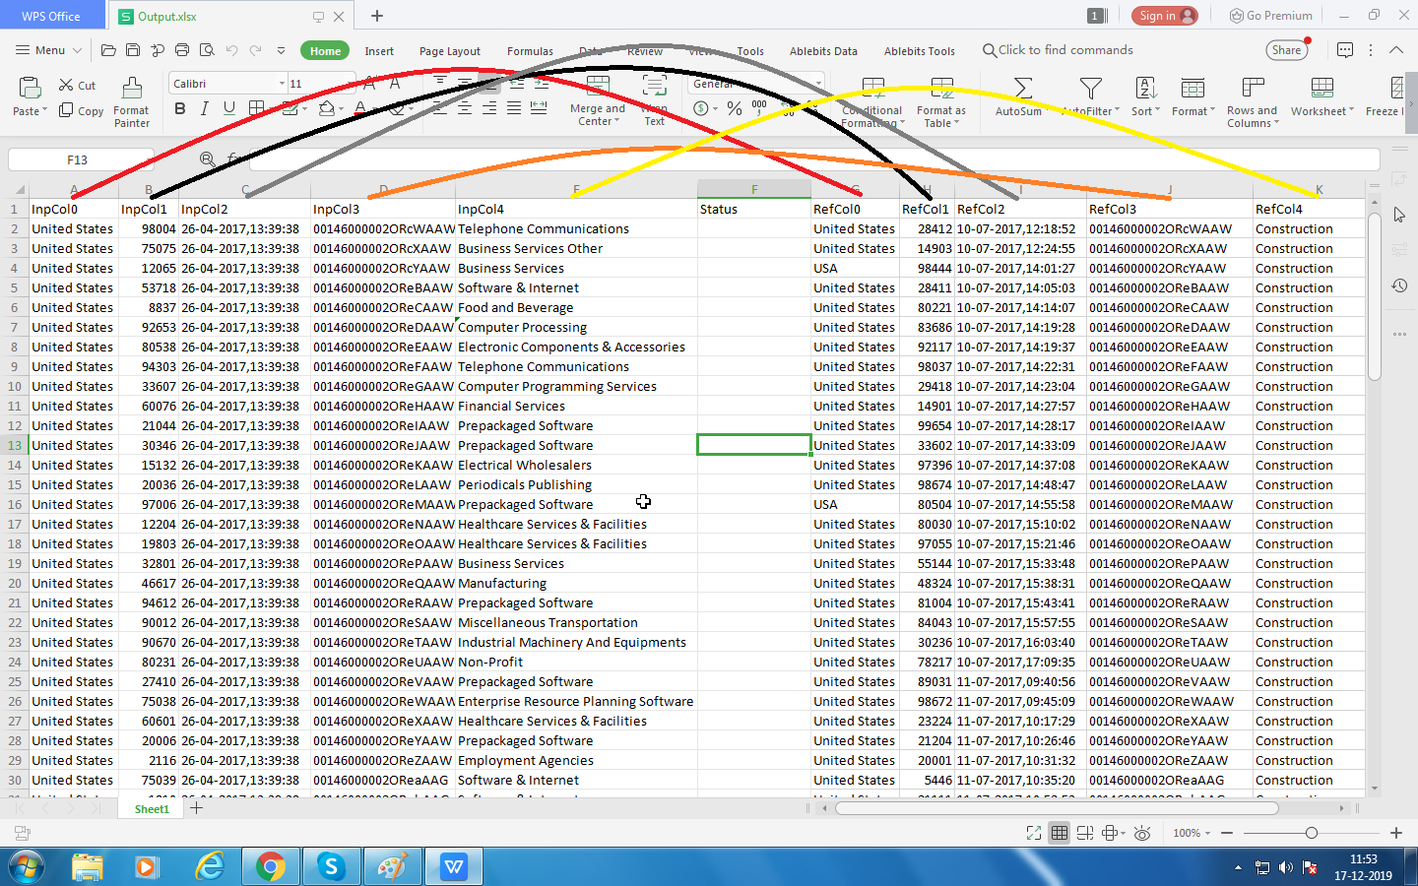

**Stage5:**

* After the comparison is done in stage4,the result of the comparison will be stored in the status field of the excel sheet.
* Out of 5 columns(row to row) comparisons,if one column(row to row) comparison fails,then the status for that row will be fail.
* If all the 5 columns(row to row) comparison are success,then the status for that row will be success.

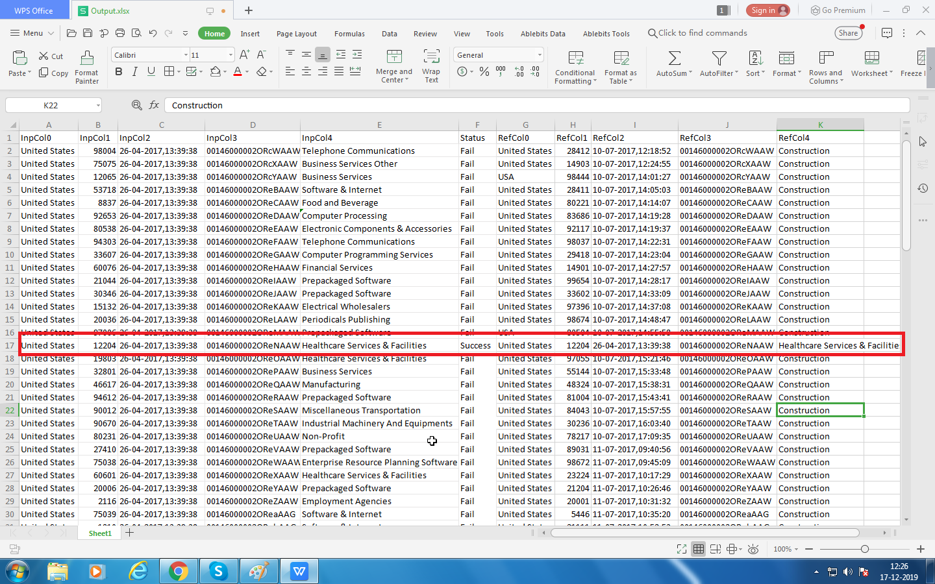

* Status will be indicated through colours.
* If the comparison status is success,the result will be shown in green colour.
* If the comparison status is fail,the result will be shown in red colour.

If status is failed.

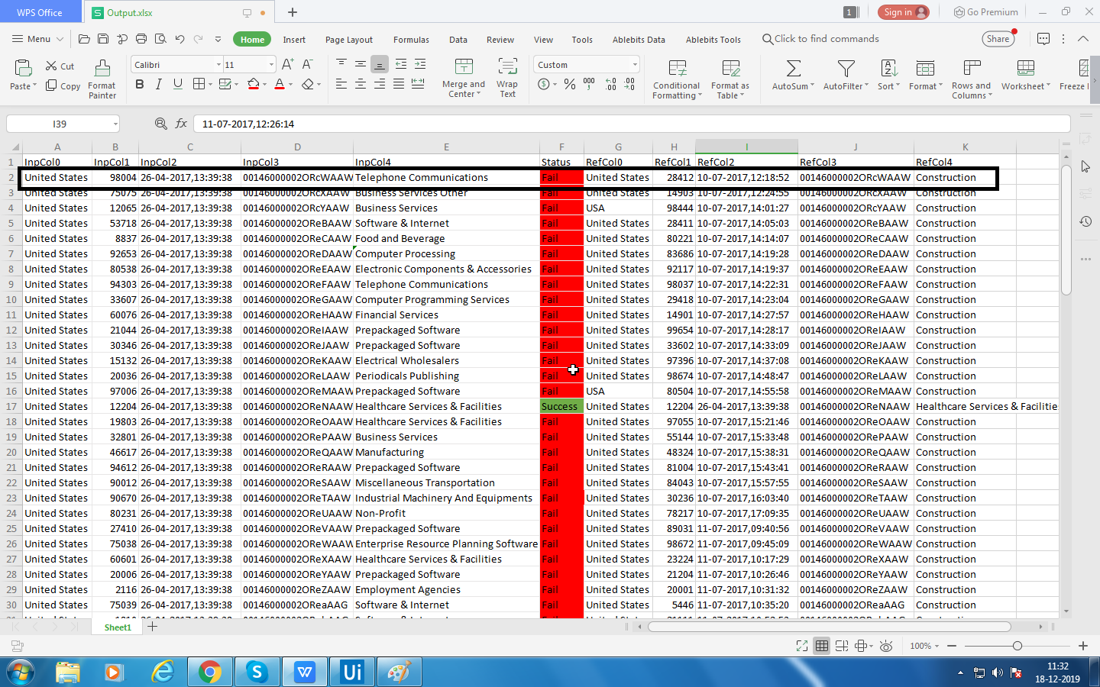

If status is success.

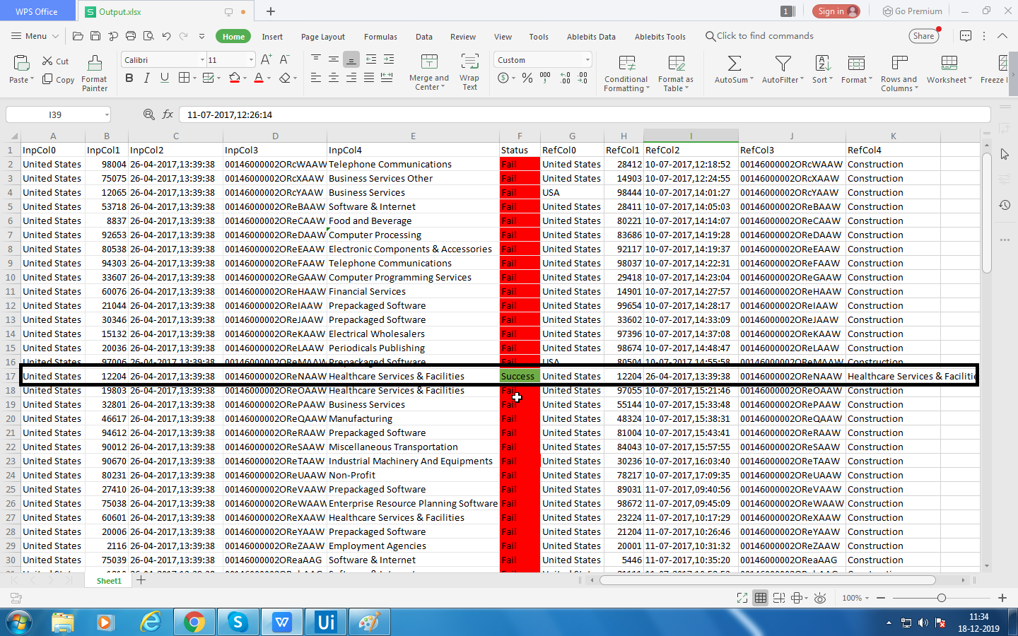

**User Manual:**

Step1:

The input sheet and reference sheet is kept in this folder.

“C:\Users\Shravanti\Desktop\Excel Bot”

Ensure only input sheet and reference sheet is found in the above folder.

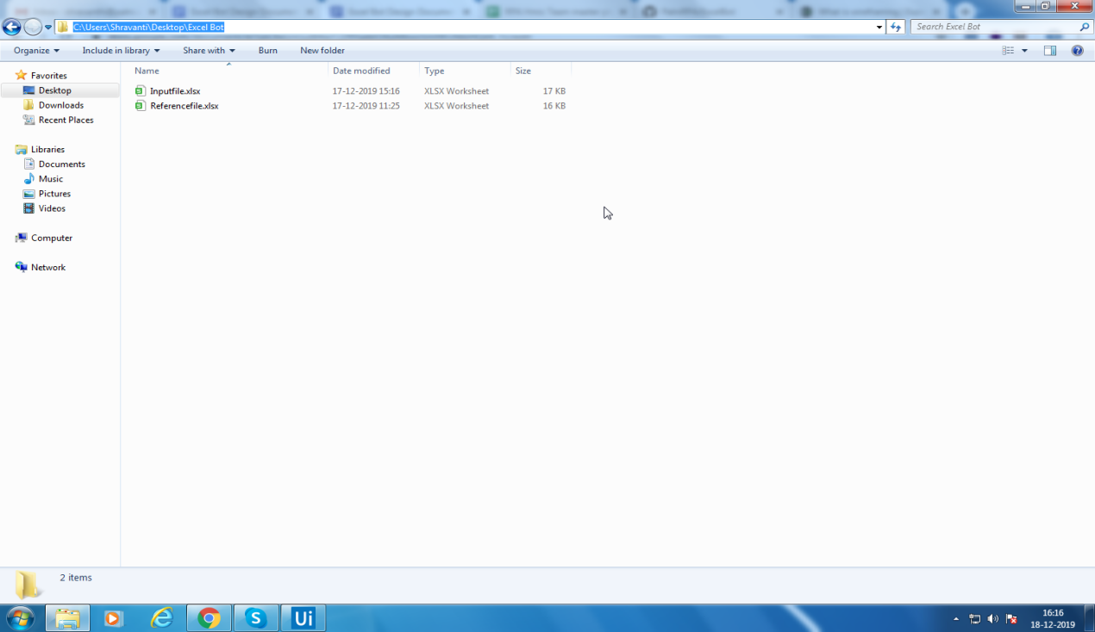

Step2:

Excel Bot Process

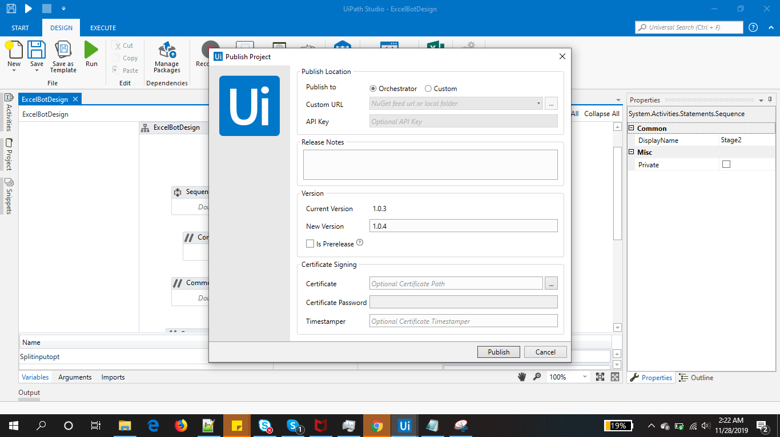

First create the process called ExcelBotDesign.And the ExcelBotDesign process is created.

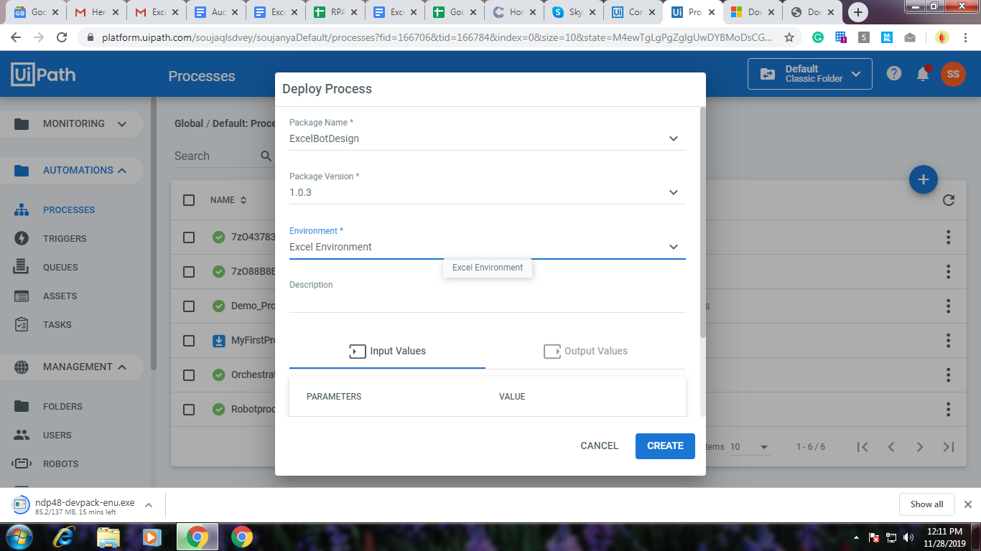

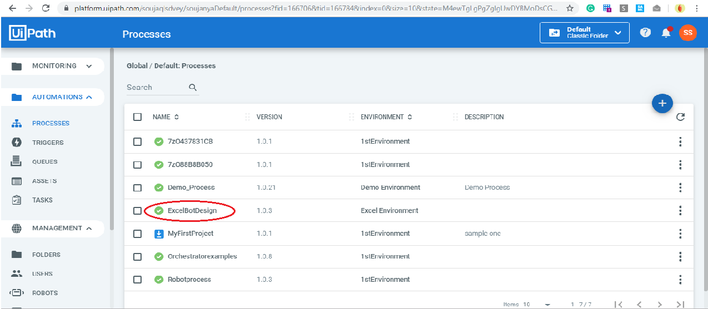

Step3:

Run the bot

To run the ExcelBotDesign process,in jobs click on the start button to run the job then select the ExcelBotDesign process and choose the “1stRobot” Bot to run.Now the process is started

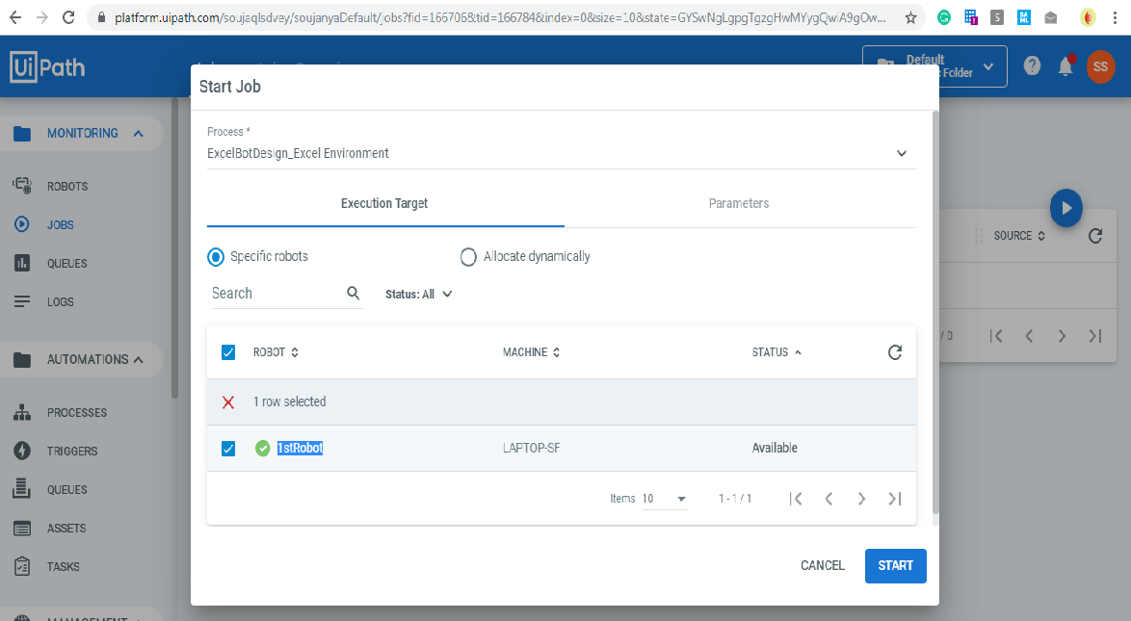

Step4:

Check status

Status of the Process can be checked under the State Column.If the Status is Successful then the process is completed.

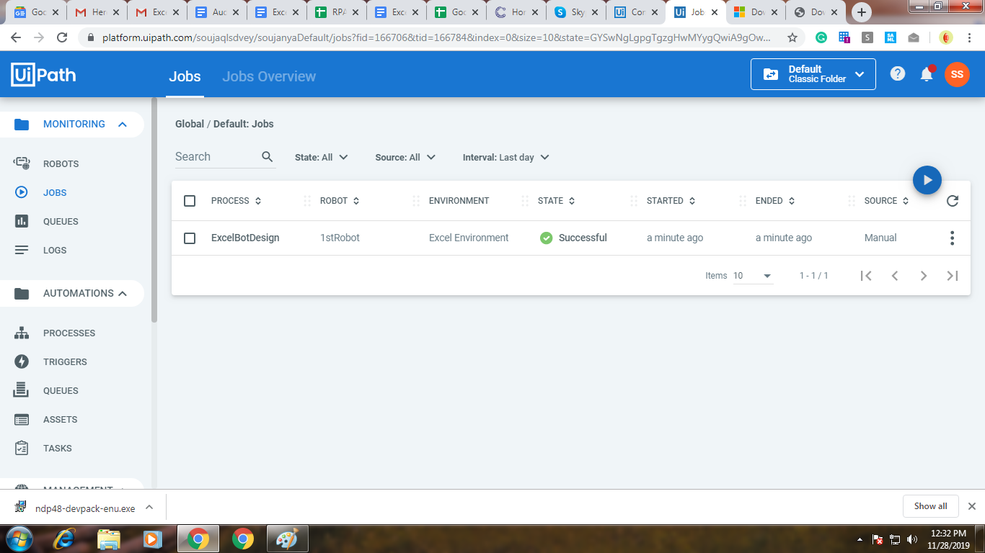

To check the Job details ,click on this details button.

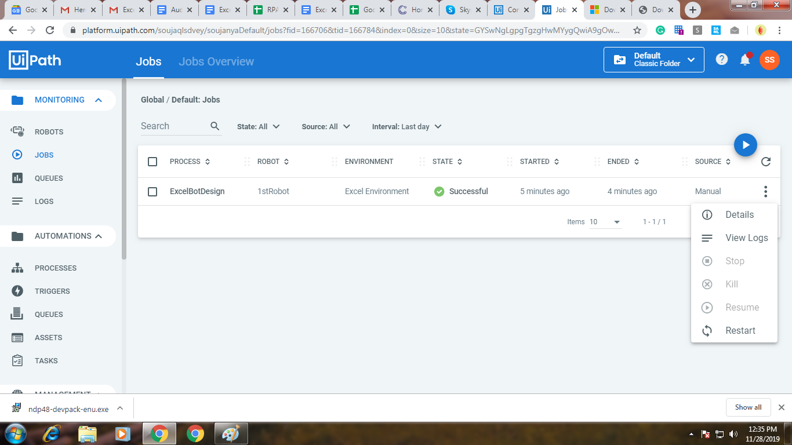

Now to check the logs for that process click on the view logs button.

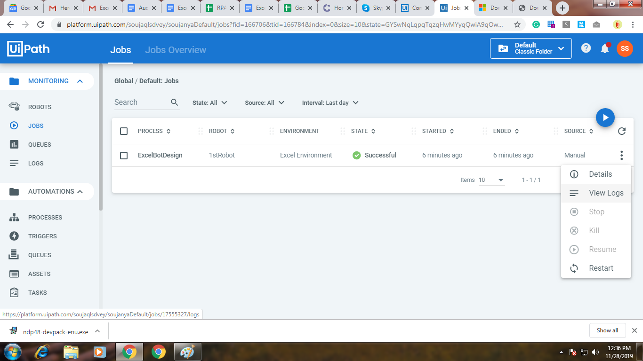

Step5:

The output file is stored in this folder

“C:\Users\Shravanti\Desktop\Excel Bot”

